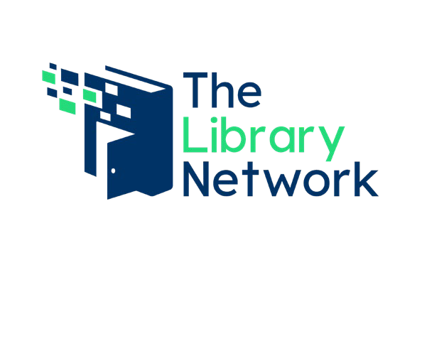
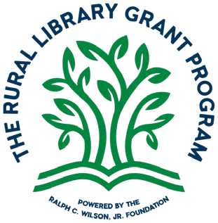
FOR IMMEDIATE RELEASE

Rural Libraries Awarded $500,000 Combined in Grants
NOVI, Mich. – June 22, 2026 – Eight rural libraries in Southeast Michigan were awarded a combined
$500,000 in grant funding for projects from The Southeast Michigan Rural Library Grant Program. Funded through the Ralph C. Wilson, Jr. Foundation, awarded grants are for specific projects that help libraries innovate as hubs for their communities.
“In many rural communities, libraries have built upon their role as hubs for learning, growing into trusted and dynamic spaces where residents can connect with resources, ideas, and one another,” said Maura Dewan, vice president of programs and corporate affairs at the Ralph C. Wilson, Jr. Foundation. “We are very proud to support library-led projects that reflect the aspirations and opportunities of the local communities and people they know best.”
Awarded grants are administered through The Library Network in partnership with Woodlands Library Cooperative and Suburban Library Cooperative. 60 library buildings across seven counties in Southeast Michigan are eligible as rural libraries.
“The Library Network is proud to partner with the Ralph C. Wilson, Jr. Foundation and help provide funding to libraries with the Rural Library Grant Program. Michigan’s rural libraries provide meaningful services to their communities and with these awards, they can do even more,” said Steven K. Bowers, executive director of The Library Network.
In the first round of applicants, the following libraries applications rose to the top, meeting one or more of the Ralph C. Wilson, Jr. Foundations interest areas:
- Addison Township Public Library received a grant in the amount of $86,950 to create an outdoor learning and gathering space featuring sensory gardens, flexible outdoor seating with awning and projector, along with accessible spaces for reading, socializing, and community programs.

- Brandon Township Public Library received a grant in the amount of $62,000 to support the installation of a 300-foot StoryWalk trail along the south side of the library property. The project will include a connection to the public sidewalk, landscaping, and installation of 16 Story Walk panels.

- Brighton District Library received a grant in the amount of $71,500 to conduct an environmental review and feasibility analysis to evaluate the viability of constructing a trail and boardwalk to connect the library property to the Charles and Albert Parker Families Nature Preserve. Funding will support professional consulting, planning, and engineering service fees.

- Ellis Library and Reference Center received a grant in the amount of $73,800 to purchase 26 outdoor musical instruments that will be permanently installed on the grounds at 6 rural library locations throughout Monroe County.

- Fowlerville District Library received a grant in the amount of $151,000 to transform an undeveloped 1,024-square-foot storage area of the library into a dedicated Teen Center. Grant

FOR IMMEDIATE RELEASE

funds will support renovation and furnishing costs, including construction, flooring, lighting, electrical work, technology, a kitchenette, tables, seating, shelving, computers, and a 3D printer.

- Lyon Township Public Library received a grant in the amount of $25,300 to outfit a new Makerspace by purchasing makerspace equipment as well as cabinetry and containers to secure equipment and materials.

- Milan Public Library received a grant in the amount of $12,800 to create a modified space configuration plan to better support early literacy and after school engagement, space, and programming for children and teens.

- Orion Township Public Library received a grant in the amount of $16,650 to update an existing trail and install a StoryWalk by Fall 2026 on its wooded property to promote literacy and outdoor activity engaging families, encouraging early literacy, and connecting the community with nature.
Grant awardees receive funding this summer. The Rural Library Grant Program scheduled round two of grant submissions later this year.
***

About Ralph C. Wilson, Jr. Foundation
The Ralph C. Wilson, Jr. Foundation is a grant-making organization dedicated primarily to sustained investment in the quality of life of the people of Southeast Michigan and Western New York. The two areas reflect Ralph C. Wilson, Jr.’s devotion to his hometown of Detroit and greater Buffalo, home of his beloved Buffalo Bills NFL team. Prior to his passing in 2014, Mr. Wilson provided that a significant share of his estate be used to continue a life-long generosity of spirit by funding the Foundation that bears his name. Based in Detroit, the Foundation began with a grant-making capacity of $1.2 billion over a 20-year period, which expires January 8, 2035. This structure is consistent with Mr. Wilson’s desire for the Foundation’s impact to be immediate, substantial, measurable, and overseen by those who knew him best. For more information visit www.rcwjrf.org.

About The Rural Library Grant Program
The Rural Library Grant Program, powered by the Ralph C. Wilson, Jr. Foundation (RCWJRF), will provide support for rural public libraries and library systems, recognizing them as key community hubs. The Foundation is providing $1.5 Million in support for a three-year period (2026-2028). The Library Network (TLN) in partnership with Woodlands Library Cooperative and Suburban Library Cooperative will design, launch, and manage this grant program for rural public libraries and library systems in Southeast Michigan, tied to the interests of the Foundation.

About The Library Network (TLN)
The Library Network (TLN) is a public library cooperative serving member libraries in southeast Michigan as well as other libraries throughout the state. Through library cooperatives the Michigan State Legislature is empowered to equitably distribute state aid to libraries to maximize the impact of shared funding for

FOR IMMEDIATE RELEASE

services to Michigan residents and visitors. The mission of TLN is "To create a vibrant, collaborative partnership among our libraries, driving access to shared services and resources." The Library Network is “Libraries Working Together.”

Contact:
DJ Bond
Communications and Member Engagement Manager, The Library Network
(248) 536-3100 x116
dbond@tln.org

